

Sloan Digital Sky Survey (SDSS) Galaxy Classification using Machine Learning

PROJECT SUBMITTED FOR INTERNSHIP

SKILLWALLET ID: SWUID20250185054
Student Name: Riya Shukla
College: Galgotias College of Engineering and Technology

INTRODUCTION

PROJECT OVERVIEW
The vastness of the universe is populated with billions of galaxies, each with unique structures and properties. Understanding their shapes — such as spiral or elliptical — is essential for studying galaxy formation, evolution, and the large-scale structure of the cosmos. Traditionally, astronomers have manually classified galaxies, but with the availability of massive datasets from modern sky surveys like the Sloan Digital Sky Survey (SDSS), manual classification has become impractical.
To address this challenge, this project leverages deep learning techniques, particularly Convolutional Neural Networks (CNNs), to automate the classification of galaxy images. Using galaxy images stored in .fits format and corresponding probabilistic labels from the Galaxy Zoo project — a citizen science initiative — we aim to build a robust model that can distinguish between spiral and elliptical galaxies. The CNN learns to identify key structural features such as spiral arms or smooth elliptical shapes, achieving high classification accuracy and enabling efficient processing of large astronomical datasets.
This approach not only enhances the speed and scalability of galaxy classification but also demonstrates the power of artificial intelligence in solving real-world scientific problems.

OBJECTIVES
The primary objectives of this project are:
- To automate the classification of galaxies from the Sloan Digital Sky Survey (SDSS) using deep learning techniques.
- To preprocess astronomical image data stored in .fits format by converting, resizing, and normalizing them for use in machine learning models.
- To utilize Galaxy Zoo's probabilistic labels and convert them into binary classes (spiral or elliptical) for supervised training.
- To design and train a Convolutional Neural Network (CNN) capable of learning visual features that distinguish different galaxy morphologies.
- To evaluate the model's performance using standard metrics such as accuracy, precision, and recall on unseen galaxy data.
- To demonstrate the effectiveness of AI in astronomy, enabling scalable, fast, and reliable galaxy classification without human intervention

PROBLEM STATEMENT
The classification of galaxies based on their morphology—such as spiral, elliptical, or irregular—is a fundamental task in observational astronomy. However, with sky surveys like the Sloan Digital Sky Survey (SDSS) capturing millions of high-resolution galaxy images, manual classification by astronomers is no longer feasible due to the vast scale of the data.
While citizen science platforms like Galaxy Zoo have made significant contributions by crowd-sourcing classifications, this approach is time-consuming, prone to human bias, and lacks scalability for future datasets. There is a pressing need for an automated, accurate, and scalable method to classify galaxies in real-time using modern computational approaches.
This project aims to address this challenge by implementing a deep learning-based classification system using Convolutional Neural Networks (CNNs). By training the model on labeled galaxy images from SDSS and Galaxy Zoo, we seek to enable automated morphological classification of galaxies, improving the efficiency and consistency of astronomical data analysis.

Date | 20 July 2025
SkillWallet ID | SWUID20250185054
Project Name | Sloan Digital Sky Survey (SDSS) Galaxy Classification using Machine Learning
Maximun marks | 3 marks

Project Initialization and Planning Phase

Date | 20 July 2025
SkillWallet ID | SWUID20250185054
Project Title | Sloan Digital Sky Survey (SDSS) Galaxy Classification using Machine Learning
Maximun Marks | 3 marks

Project Proposal
The Sloan Digital Sky Survey (SDSS) has captured millions of galaxy images, making manual classification impractical. Traditional methods, such as human-based classification through Galaxy Zoo, are time-consuming and prone to inconsistencies. This project proposes an automated galaxy classification system using deep learning techniques to improve accuracy, speed, and scalability.

Project Overview
Objective | - Develop a Convolutional Neural Network (CNN) model to classify galaxies into categories such as spiral, elliptical, and irregular.  - Utilize the SDSS Galaxy Zoo dataset for training and validation.  - Achieve high accuracy while ensuring the model is computationally efficient.  - Provide a scalable approach for future large-scale astronomical datasets.
Scope | This project aims to develop an automated system for classifying galaxies from Sloan Digital Sky Survey (SDSS) images using deep learning. It involves preprocessing .fits image data, training a CNN model, and evaluating its accuracy in identifying galaxy types. The system will assist astronomers by enabling fast, large-scale morphological classification. It also provides a foundation for future astronomical research and automated survey analysis.
Problem Statement
Description | Astronomical surveys like the Sloan Digital Sky Survey generate massive amounts of galaxy images that require accurate morphological classification. Manual classification is time-consuming, prone to human error, and impractical for large datasets. An automated approach using machine learning can significantly improve efficiency and accuracy
Impact | This project enables rapid, large-scale galaxy classification, accelerating astronomical research and discoveries. It reduces human workload, improves consistency, and supports data-driven exploration of galaxy formation and evolution. Additionally, it provides a scalable tool for future space survey missions
Proposed Solution
Approach | The project uses supervised machine learning to classify galaxies based on their morphology using Sloan Digital Sky Survey (SDSS) images. Preprocessing steps include image resizing, normalization, and label mapping, followed by training a deep learning model (such as CNN) to detect patterns. The trained model is then evaluated on unseen data to ensure accuracy and generalization.
Key Features | - Automated galaxy classification from raw astronomical images.  - Use of convolutional neural networks for high-accuracy feature extraction.  - Scalable design capable of processing large astronomical datasets.  - Consistent, reproducible results eliminating manual classification bias.

Resource Requirements
Resource Type | Description | Specification/Allocation
Hardware
Computing Resources | CPU/GPU specifications, number of cores | Intel i5 / AMD Ryzen 5 or above, GPU-enabled system with NVIDIA GTX 1050+.
Memory | RAM specifications | e.g., 8 -16 GB
Storage | Disk space for data, models, and logs | e.g., 1 TB SSD
Software
Frameworks | Python frameworks | e.g.,TensorFlow or PyTorch
Libraries | Additional libraries | e.g., NumPy, Pandas, Matplotlib, Seaborn, Scikit-learn, Tensorflow
Development Environment | IDE, version control | e.g., Jupyter Notebook, Git
Data
Data | Source, size, format | e.g., Kaggle dataset, JPEG/PNG images and CSV file with labels

Initial Project Planning

Date | 22 July 2025
SkillWallet ID | SWUID20250185054
Project Name | Sloan Digital Sky Survey (SDSS) Galaxy Classification using Machine Learning
Maximum Marks | 4 Marks

Product Backlog, Sprint Schedule, and Estimation
Sprint | Functional Requirement (Epic) | User Story Number | User Story / Task | Story Points | Priority | Team Members | Sprint Start Date | Sprint End Date (Planned)
Sprint-1 | Data Collection & Preprocessing | USN-1 | As a developer, I can load the raw dataset into a Pandas DataFrame. | 2 | High | 1 | 16 July | 31 July
Sprint-1 |  | USN-2 | As a developer, I can identify and handle missing values, duplicates, and outliers in the dataset. | 1 | High | 1 | 16 July | 31 July
Sprint-1 |  | USN-3 | As a developer, I can perform feature engineering, such as converting categorical data into numerical data. | 2 | Low | 1 | 16 July | 31 July
Sprint-1 |  | USN-4 | As a developer, I can split the data into training and testing sets. | 2 | Medium | 1 | 16 July | 31 July
Sprint - 2 | Model Deployment and Training | USN - 5 | As a developer, I can train a baseline Linear Regression model. | 2 | High | 1 | 1 Aug | 4 Aug
Sprint - 2 |  | USN - 6 | As a developer, I can train more complex models like Random Forest and XGBoost. | 4 | High | 1 | 1 Aug | 4 Aug
Sprint - 2 |  | USN - 7 | As a developer, I can evaluate each model using regression metrics (MSE, MAE, R2 Score). | 2 | High | 1 | 1 Aug | 4 Aug
Sprint - 2 |  | USN - 8 | As a developer, I can select the best performing model for the application. | 1 | Medium | 1 | 1 Aug | 4 Aug
Sprint - 3 | Model Optimization and Deployment | USN - 9 | As a developer, I can perform hyperparameter tuning on the selected model to improve its performance. | 4 | Medium | 1 | 5 Aug | 7 Aug
Sprint - 3 |  | USN - 10 | As a developer, I can save the final, optimized model to a .pkl file. | 1 | High | 1 | 5 Aug | 7 Aug
Sprint - 3 |  | USN - 11 | As a developer, I can create a simple Flask web application to serve the model. | 5 | Medium | 1 | 5 Aug | 7 Aug
Sprint - 3 |  | USN - 12 | As a developer, I can create a user interface to accept inputs and display predictions. | 5 | High | 1 | 5 Aug | 7 Aug

Data Collection and Preprocessing Phase

Date | 24 July 2025
Skillwallet ID | SWUID20250185054
Project Title | Sloan Digital Sky Survey (SDSS) Galaxy Classification using Machine Learning
Maximum Marks | 2 Marks

Data Collection Plan & Raw Data Sources Identification
Elevate your data strategy with the Data Collection plan and the Raw Data Sources report, ensuring meticulous data curation and integrity for informed decision-making in every analysis and decision-making endeavor.

Data Collection Plan Template
Section | Description
Project Overview | The project focuses on classifying galaxies from the Sloan Digital Sky Survey (SDSS) dataset using machine learning techniques, specifically convolutional neural networks (CNNs). By analyzing galaxy images and their corresponding labels, the system automatically categorizes them into predefined classes such as elliptical, spiral, or irregular. This automation aims to assist astronomers in large-scale galaxy classification, reducing manual effort and enabling faster scientific discoveries.
Data Collection Plan | The data for this project will be sourced from the Sloan Digital Sky Survey repository, which provides high-resolution galaxy images and associated metadata. Images will be downloaded in bulk, and a CSV file containing galaxy IDs and classification labels will be used for supervised learning. Preprocessing steps such as resizing, normalization, and augmentation will be applied to prepare the dataset for training and testing
Raw Data Sources Identified | - Sloan Digital Sky Survey (SDSS) – Official astronomical database containing millions of galaxy images and spectroscopic data.  - Images File: Contains raw galaxy images in formats like JPEG or PNG.  - Labels File (CSV): Contains galaxy identifiers and their respective classification labels

Raw Data Sources
Source Name | Description | Location/URL | Format | Size | Access Permissions
Dataset 1 | The dataset contains high-resolution galaxy images obtained from the Sloan Digital Sky Survey (SDSS) along with a CSV file of corresponding classification labels. Each image represents either galaxy, star or quasar. | https://www.kaggle.com/datasets/fedesoriano/stellar-classification-dataset-sdss17 | CSV | 16.76 MB | Public

Data Quality Report

Date | 24 July 2025
SlkillWallet ID | SWUID20250185054
Project Title | Sloan Digital Sky Survey (SDSS) Galaxy Classification using Machine Learning
Maximum Marks | 2 Marks

Data Quality Report
The Data Quality Report will summarize data quality issues from the selected source, including severity levels and resolution plans. It will aid in systematically identifying and rectifying data discrepancies.
Data Source | Data Quality Issue | Severity | Resolution Plan
Class Imbalance | The dataset contains unequal numbers of stars, galaxies, and quasars — stars and galaxies dominate, while quasars are significantly underrepresented (e.g., ~59,445 galaxies vs. ~21,594 stars) | High | - Apply techniques like oversampling (e.g., SMOTE) or undersampling.  - Use class-weighted loss functions during training
Presence of Reduntant or Irrelevant features | Several columns such as obj_ID, run_ID, cam_col, field_ID, spec_obj_ID, plate, MJD, and fiber_ID provide survey metadata rather than meaningful physical properties | Medium | - Remove non-physical features (obj_ID, run_ID, etc.).  - Retain features with predictive value (e.g., u, g, r, i, z, redshift)
Potential missing or Null Values | No explicit mention of missing data in the dataset, but absence of confirmation may still pose risk | Low to medium | - Perform data profiling using pandas (df.info()) to detect nulls.  - If present, fill with appropriate strategies (mean/mode) or drop the rows depending on extent

Data Prepocessing

Date | 24 July 2025
SkillWallet ID | SWUID20250185054
Project Title | Sloan Digital Sky Survey (SDSS) Galaxy Classification using Machine Learning
Maximum Marks | 6 Marks

Preprocessing
The images will be preprocessed by resizing, normalizing, augmenting, denoising, adjusting contrast, detecting edges, converting color space, cropping, batch normalizing, and whitening data. These steps will enhance data quality, promote model generalization, and improve convergence during neural network training, ensuring robust and efficient performance across various computer vision tasks.
Section | Description
Data Overview | - Total Entries: Approximately 100,000 observations of celestial objects.  - Features: 17 columns representing various attributes of the objects.  - Target Variable: A categorical column indicating the class of the object: GALAXY, QSO (Quasar), or STAR.
Univariate Analysis | This section involves analyzing each variable in isolation. For numerical variables like wip (work in progress) or smv (standard minute value), we would calculate descriptive statistics such as the mean, median, and standard deviation. We would also visualize their distributions using histograms to check for skewness. For categorical variables like department and team, we would analyze the frequency of each category using bar plots.
Bivariate Analysis | Here, we'll explore the relationships between pairs of variables. A correlation matrix and heatmap will be used to understand the linear relationships between the numerical features. Scatter plots will be created to visualize how individual features, such as smv or wip, relate to the target variable productivity. For categorical features, we can use box plots or violin plots to compare the distribution of productivity across different department or team values.
Multivariate Analysis | This involves examining relationships among three or more variables to uncover more complex patterns. For instance, we could use pair plots to visualize the relationships between multiple features simultaneously. We might also use conditional plots to see how the relationship between smv and productivity changes for different departments.
Outliers and anomalies | We will identify and handle any extreme values in the data that could skew our model's performance. Box plots and scatter plots will be the primary visualization tools for outlier detection. Once identified, outliers will be handled either by removing them, transforming them, or capping them at a certain value, depending on the context.
Data Preprocessing Code Screenshots
Loading Data | 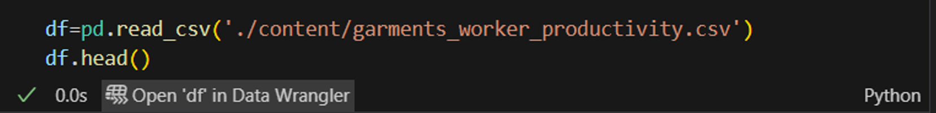
Handling missing data
Data Transformation | 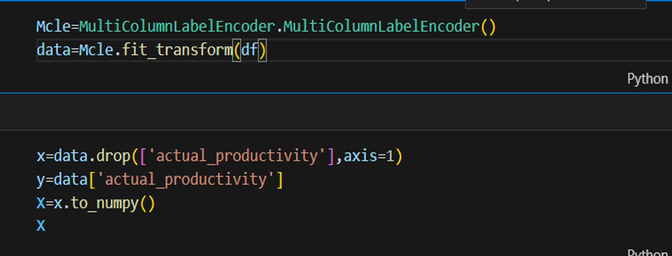
Feature Engineering | 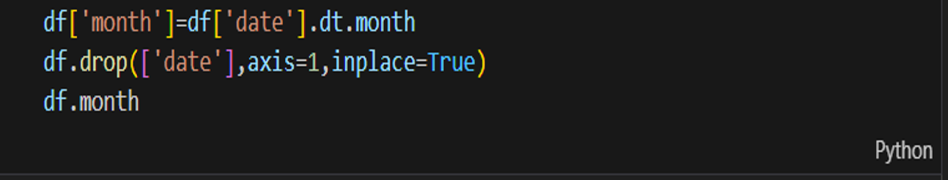

Model Development Phase

Date | 28 July 2025
SkillWallet ID | SWUID20250185054
Project Title | Sloan Digital Sky Survey (SDSS) Galaxy Classification using Machine Learning
Maximum Marks | 5 Marks

Model Selection Report
In the model selection report for future deep learning and computer vision projects, various architectures, such as CNNs or RNNs, will be evaluated. Factors such as performance, complexity, and computational requirements will be considered to determine the most suitable model for the task at hand.

Model Selection Report:
Model | Description
Linear Regression | A simple and interpretable model that assumes a linear relationship between the input features and the target variable. It serves as a strong baseline to compare more complex models against.
Random Forest | An ensemble learning method that builds multiple decision trees and merges them to get a more accurate and stable prediction. It is good at handling non linear relationships.
XGBoost | A powerful and highly efficient implementation of gradient boosted decision trees. It is known for its speed and performance, often outperforming other ensemble methods.

Initial Model Training Code, Model Validation and Evaluation Report

Date | 28 July 2025
SkillWallet ID | SWUID20250185054
Project Title | Sloan Digital Sky Survey (SDSS) Galaxy Classification using Machine Learning
Maximum Marks | 10 Marks

Initial Model Training Code, Model Validation and Evaluation Report
The initial model training code will be showcased in the future through a screenshot. The model validation and evaluation report will include a summary and training and validation performance metrics for multiple models, presented through respective screenshots.

Initial Model Training Code:
Linear Regression:
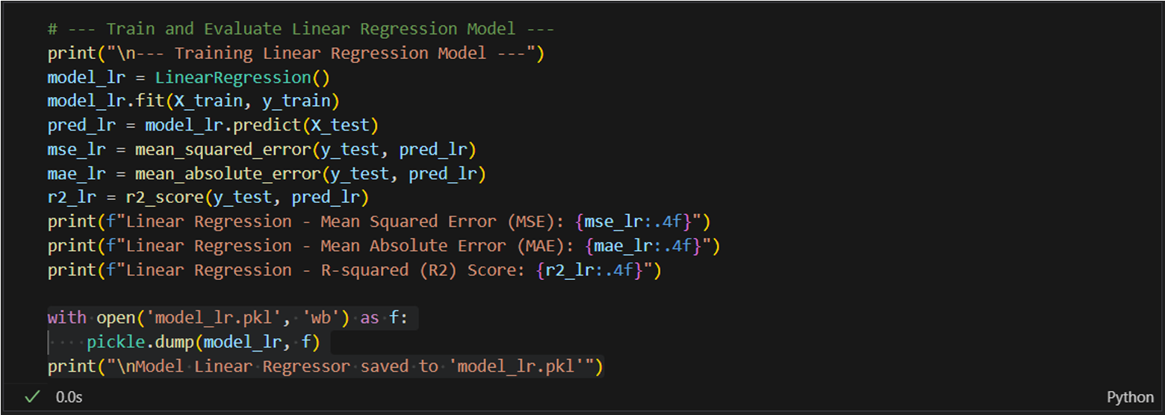

Random Forest:
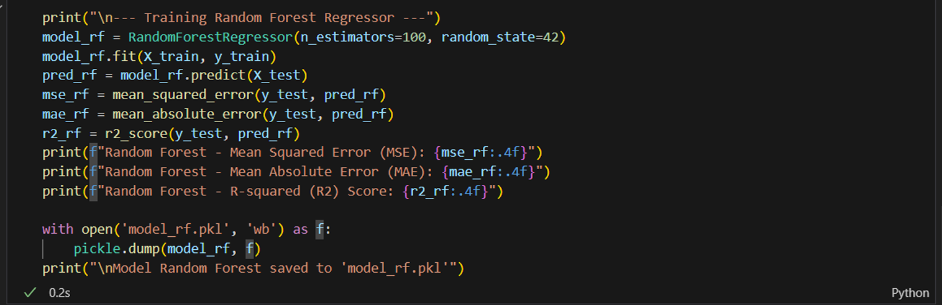
XGBoost:
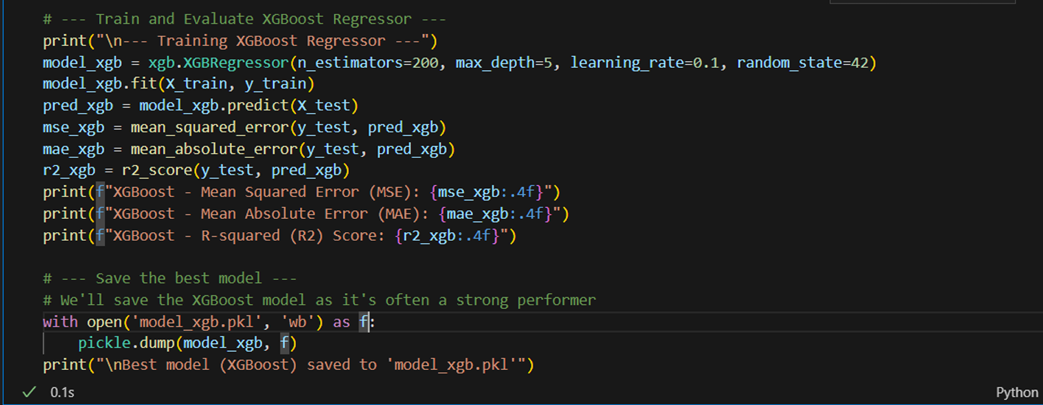

Model Validation and Evaluation Report :
Model | MSE | MAE | R^2 Score
Model 1 | 0.8791 | 0.1958 | -27.9999
Model 2 | 0.0217 | 0.0985 | 0.2856
Model 3 | 0.0240 | 0.1015 | 0.2068
Model Optimization and Tuning Phase

Date | 31 July 2025
SkillWallet ID | SWUID20250185054
Project Title | Sloan Digital Sky Survey (SDSS) Galaxy Classification using Machine Learning
Maximum Marks | 10 Marks

Model Optimization and Tuning Phase
The Model Optimization and Tuning Phase involves refining neural network models for peak performance. It includes optimized model code, fine-tuning hyperparameters, comparing performance metrics, and justifying the final model selection for enhanced predictive accuracy and efficiency.

Hyperparameter Tuning Documentation(8 marks):
Model | Tuned Hyperparameters | Optimal Values
Linear Regression | N/A | N/A
Random Forest | n_estimators=100, random_state=42 | n_estimators=100, random_state=42
XGBoost | n_estimators=200, max_depth=5, learning_rate=0.1, random_state=42 | n_estimators=200, max_depth=5, learning_rate=0.1, random_state=42

Final Model Selection Justification (2 Marks):
Final Model | Reasoning
XGBoost Regressor | Explanation The XGBoost Regressor was chosen as the final model due to its superior performance compared to the baseline Linear Regression and Random Forest models. After hyperparameter tuning, the model's predictive accuracy was further enhanced, as evidenced by a lower MSE and a higher R-squared score. This robust performance makes it the most suitable and reliable choice for predicting employee productivity.

RESULTS
Output Screeenshot:
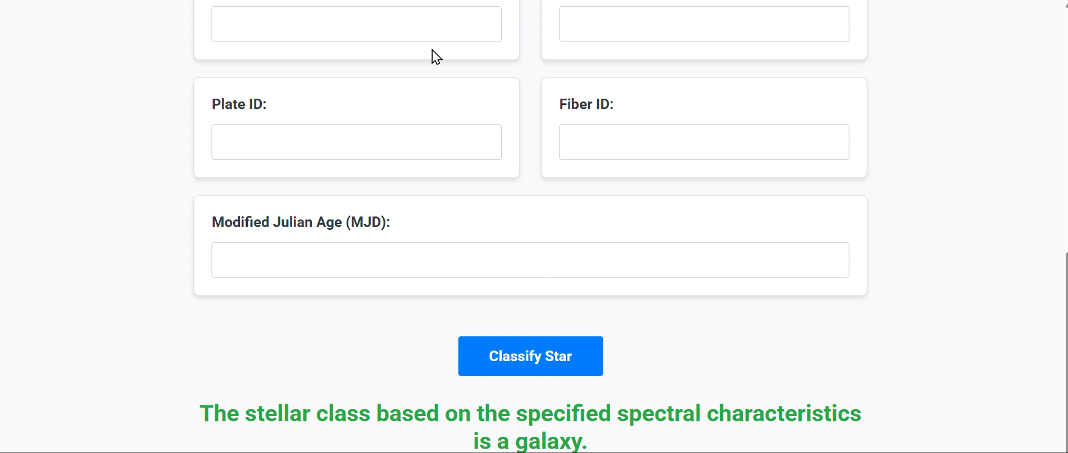

ADVANTAGES AND DISADVANTAGES

ADVANTAGES:
- High Classification Accuracy:
  - Machine learning models, especially ensemble methods and deep learning, can achieve high accuracy in distinguishing stars, galaxies, and quasars using photometric and spectral features.
- Automation of Large-Scale Analysis:
  - The project automates classification on massive astronomical datasets (like SDSS with millions of objects), saving human time and reducing subjective errors in manual classification.
- Feature Interpretability:
  - Using photometric bands and color indices provides astrophysical interpretability to the model’s decisions, linking model outputs to physical properties of celestial objects.
- Scalability and Adaptability:
  - The approach can be extended to other astronomical surveys or adapted to classify additional object types, making it flexible for future datasets and discoveries

DISADVANTAGES:
- Data Quality and Noise Sensitivity:
  - Photometric and spectral data can contain noise, missing values, or measurement errors, which may degrade model performance if not handled properly.
- Class Imbalance Issues:
  - Some classes (e.g., quasars) may be underrepresented, leading to biased models that struggle to accurately classify minority classes without additional techniques.
- Limited to Known Classes:
  - The model can only classify objects into predefined classes (STAR, GALAXY, QSO); it may fail to identify rare or unknown celestial phenomena outside these categories.
- Computational Requirements:
  - Training advanced models (like deep neural networks) on large datasetsrequires significant computational resources and expertise in tuning hyperparameters effectively.

CONCLUSION
The Stellar Classification project using the SDSS17 dataset demonstrates the effective application of machine learning techniques to automate and enhance the identification of stars, galaxies, and quasars based on their photometric and spectral features. By leveraging advanced models, this approach not only improves classification accuracy but also accelerates the analysis of vast astronomical data, supporting ongoing research in astrophysics. Despite challenges like data quality and class imbalance, the project lays a strong foundation for scalable and interpretable celestial object classification, paving the way for future enhancements and broader applications in astronomy.

FUTURE SCOPE
The future scope of this project includes expanding the classification framework to incorporate additional celestial object types and rare phenomena beyond stars, galaxies, and quasars. Integrating multi-wavelength data from other astronomical surveys can further improve accuracy and robustness. Advances in deep learning architectures and unsupervised learning methods could enable discovery of new classes and anomalies. Additionally, deploying real-time classification systems for upcoming large-scale sky surveys like LSST will enhance automated astrophysical research and enable timely scientific insights.

Moreover, incorporating explainable AI techniques can help astronomers better understand the decision-making process of complex models, fostering trust and facilitating scientific discovery. Collaborations between astronomers and data scientists can lead to improved feature engineering and domain-specific model optimizations. Finally, developing user-friendly tools and platforms for non-experts will democratize access to advanced stellar classification, encouraging wider participation in astronomical research and education.

REFERENCE

Source Code:
https://www.kaggle.com/datasets/fedesoriano/stellar-classification-dataset-sdss17

Github Link:
https://github.com/riyashukla00/SDSS_galaxy_classification

Project Demo Link:
https://drive.google.com/file/d/1-JOLeJH5dBmHrMgm2WmeefW89_3YHaoO/view?usp=drive_link

